CSC 122 001 Computer Science II

Julius Ranoa

Midterm – Practical Exam.

Objectives:

1. Create a template linked list with methods to add/remove/print the list.
2. Modify the above linked list to include a member function to insert a new item at a specified position. A position of 0 means that the value will become the first item on the list, a position of 1 means that the value will become the second item on the list, and so on. A position equal to or greater than the length of the list means that the value is placed at the end of the list. Call this member function *“insertAtPos”*.
3. Demonstrate the usage of the above linked list using strings and char from *main.cpp*.

Screenshot of runtime:

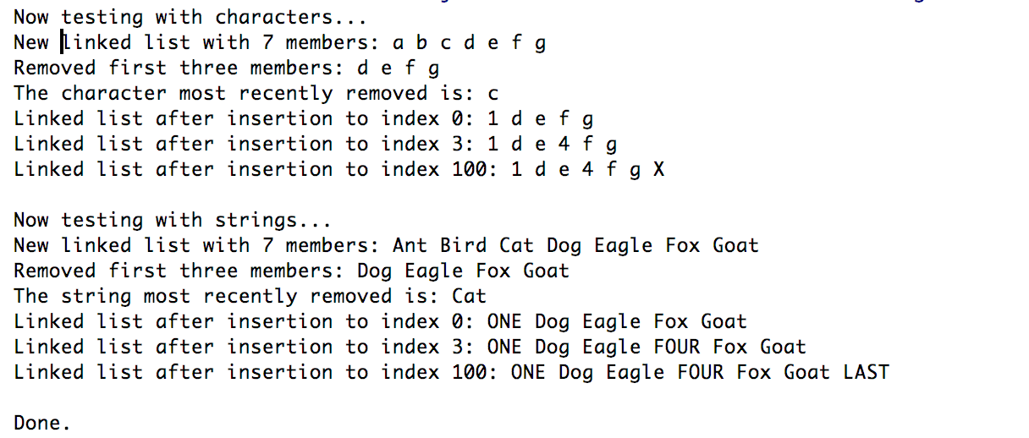

Files included: (1) main.cpp, (2) LinkedList.h

**main.cpp**

#include **<iostream>**#include **<string>**#include **"LinkedList.h"  
  
void** testWithChars();  
**void** testWithStrings();  
  
**int** main() {  
 std::cout << **"Now testing with characters... \n"**;  
 testWithChars();  
 std::cout << **"\n"**;  
  
 std::cout << **"Now testing with strings... \n"**;  
 testWithStrings();  
 std::cout << **"\n"**;  
  
 std::cout << **"Done. "**;  
 **return** 0;  
}  
  
**void** testWithChars() {  
 LinkedList<**char**> characterList;  
 *// Make a linked list of 7 characters.* **char** charTest[] = { **'g'**, **'f'**, **'e'**, **'d'**, **'c'**, **'b'**, **'a'** };  
 **for** (**char** c : charTest) {  
 characterList.addItem(c);  
 }  
 std::cout << **"New linked list with 7 members: "**;  
 characterList.print();  
 std::cout << **"\n"**;  
  
 *// Remove the first three characters.* std::cout << **"Removed first three members: "**;  
 **for** (**int** i = 0; i < 2; i++) characterList.popItem();  
 **char** charLastPopped = characterList.popItem();  
 characterList.print();  
 std::cout << **"\n"**;  
 std::cout << **"The character most recently removed is: "** << charLastPopped << **"\n"**;  
  
 *// Insert at Position Tests* characterList.insertAtPos(**'1'**, 0);  
 std::cout << **"Linked list after insertion to index 0: "**;  
 characterList.print();  
 std::cout << **"\n"**;  
  
 characterList.insertAtPos(**'4'**, 3);  
 std::cout << **"Linked list after insertion to index 3: "**;  
 characterList.print();  
 std::cout << **"\n"**;  
  
 characterList.insertAtPos(**'X'**, 100);  
 std::cout << **"Linked list after insertion to index 100: "**;  
 characterList.print();  
 std::cout << **"\n"**;  
}  
  
**void** testWithStrings() {  
 LinkedList<std::string> characterList;  
 *// Make a linked list of 7 strings.* std::string stringTest[] = { **"Goat"**, **"Fox"**, **"Eagle"**, **"Dog"**, **"Cat"**, **"Bird"**, **"Ant"** };  
 **for** (std::string s : stringTest) {  
 characterList.addItem(s);  
 }  
 std::cout << **"New linked list with 7 members: "**;  
 characterList.print();  
 std::cout << **"\n"**;  
  
 *// Remove the first three characters.* std::cout << **"Removed first three members: "**;  
 **for** (**int** i = 0; i < 2; i++) characterList.popItem();  
 std::string lastPopped = characterList.popItem();  
 characterList.print();  
 std::cout << **"\n"**;  
 std::cout << **"The string most recently removed is: "** << lastPopped << **"\n"**;  
  
 *// Insert at Position Tests* characterList.insertAtPos(**"ONE"**, 0);  
 std::cout << **"Linked list after insertion to index 0: "**;  
 characterList.print();  
 std::cout << **"\n"**;  
  
 characterList.insertAtPos(**"FOUR"**, 3);  
 std::cout << **"Linked list after insertion to index 3: "**;  
 characterList.print();  
 std::cout << **"\n"**;  
  
 characterList.insertAtPos(**"LAST"**, 100);  
 std::cout << **"Linked list after insertion to index 100: "**;  
 characterList.print();  
 std::cout << **"\n"**;  
}

**LinkedList.h**

*//  
// Created by TheLoneWoof on 3/8/18.  
//*#ifndef **EXAM_MIDTERM_LINKEDLIST_H**#define **EXAM_MIDTERM_LINKEDLIST_H**#include **<iostream>***// TEMPLATE DEFINITION***template** <**class** T>  
**class** LinkedList {  
  
**private**:  
 **struct** ListItem {  
 T value;  
 ListItem * next;  
 ListItem(T val, ListItem * ptr) {  
 value = val;  
 next = ptr;  
 }  
 };  
 ListItem * firstItem;  
  
**public**:  
 LinkedList() {  
 firstItem = **nullptr**;  
 }  
  
 *// Objective 1. Add, Remove, and Print.* **void** addItem(T val);  
 T popItem();  
 **void** print();  
  
 *// Objective 2. Insert at position method.* **void** insertAtPos(T, **unsigned**);  
};  
  
*// IMPLEMENTATION***template** <**class** T>  
**void** LinkedList<T>::addItem(T val) {  
 firstItem = **new** ListItem(val, firstItem);  
}  
  
**template** <**class** T>  
T LinkedList<T>::popItem() {  
 *// Pop the item in front of the list.* ListItem * tempReference;  
 T poppedItem;  
  
 *// Make duplicates of the first item.* tempReference = firstItem;  
 poppedItem = firstItem->value;  
  
 *// Fix the list.* firstItem = firstItem->next;  
 tempReference->next = **nullptr**;  
 **delete** tempReference;  
  
 **return** poppedItem;  
}  
  
**template** <**class** T>  
**void** LinkedList<T>::print() {  
 ListItem * temp;  
 temp = firstItem;  
 **while** (temp) {  
 std::cout << temp->value << **" "**;  
 temp = temp->next;  
 }  
}  
  
**template** <**class** T>  
**void** LinkedList<T>::insertAtPos(T item, **unsigned** index) {  
 **if** (index == 0) {  
 *// If index == 0, then add item to the beginning.* addItem(item);  
 } **else** {  
 *// If index > 1, then insert item between lists.* ListItem * prevItem, * currItem, * newItem;  
 **int** i = 1;  
  
 prevItem = firstItem;  
 currItem = firstItem->next;  
 *// Loop through i or until last of list.* **while** (i < index && currItem) {  
 i++;  
 prevItem = currItem;  
 currItem = currItem->next;  
 }  
  
 *// Insert item.* newItem = **new** ListItem(item, currItem);  
 prevItem->next = newItem;  
  
 *// Dereference the pointers.* newItem = **nullptr**;  
 prevItem = **nullptr**;  
 currItem = **nullptr**;  
 }  
}  
  
  
#endif *//EXAM_MIDTERM_LINKEDLIST_H*